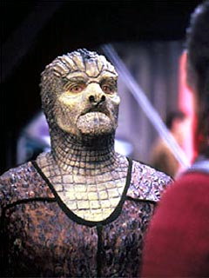
Tosk & the Hunters
By DanG

The Tosk.
Affiliation; None
Homeworld; Unknown (Gamma Quadrant)
The Tosk were artificially created by the species known as 'The Hunters' to be the prey in massive hunts they hold. The Tosk lead a gentle privileged life secluded in their own planet in the Hunters system. Fully aware of their history and links to the Hunters, the Tosk consider it a great privilege to become the quarry of the hunt, and as such accept the hunters code as their own.

Indeed the greatest shame amongst Tosk society is to be hunted but captured alive and paraded for the Tosk people to see that your hunt was over quickly before living the rest of your life in shame.
Tosk
Attributes:
Fitness; 3
Co-ordination; 2,
Dexterity +1
Intellect; 2,
Perception +1
Presence; 2,
Empathy -1,
Willpower -2
Psi; 0
Skills:
Athletics (Choose Specialisation) 2 (3)
Culture (Tosk) 2 (3)
History (Tosk and Hunters) 1 (2)
Language; Hunters 2
Stealth (Shrouded) 2 (3)
Word Knowledge (Homeworld) 1 (2)
or
Planetary Survival (Choose Specialisation) 1 (2)

Typical Advantages/Disadvantages:
Code of Honour (Hunters Code) -2
Shroud +5 (See DS9 core rulebook)

Note; If encountered while being hunted, the Tosk will also have the Disadvantage;
Marked Man -3, in addition another skill of the players choice at level 1 (2).

Code of Honour (Hunters Code) -2
This code of honour is developed purely as a credo between the Hunters and the Tosk, both groups believe in it to an almost religious level. This code of honour allows the Tosk free reign to lead the hunt wherever they may wish, and give the Tosk a reasonable head start. Some Tosk have even led the Hunt off-planet thanks to this.
Once the hunt has begun in earnest the Tosk may accept help, but may not reveal the nature of the hunt, nor ask for help. It must be freely given, and a Tosk may be joined by others of their own free will. These others will also become objects of the hunt. The hunt will continue until either the quarry is killed or captured in shame, or until all the hunters are dead.
The Tosk are genetically engineered with the ability to become invisible, like the Jem'Hadar, this has become known as 'Shroud', from Dominion Terminology. By doing so the 'shrouded' character disappears and it would require a Search or Intellect test at +4 difficulty to find the hidden character. This is a defensive action and unlike the Jem’Hadar a shrouded Tosk must make a successful Stealth check to remain concealed.
This ability along with the reptilian nature of both the Tosk and Hunters, and the admission that the Tosk were an artificially created species specifically for the purpose of hunting. Along with the hunters choice of Dominion energy weapons has led Starfleet Intelligence to make much speculation from the sole encounter with either of these species at DS9 in 2369, and speculation seems to point to the Tosk as perhaps a prototype for the Jem’Hadar with the Hunters perhaps serving as original genetic stock, however no proof of this speculation has been substantiated. To date the hunters have kept their word and never brought their hunt through the wormhole again, baring travel through it as part of the rules of future hunts, and Starfleet has been unable to locate their homeworld. See also The Hunters
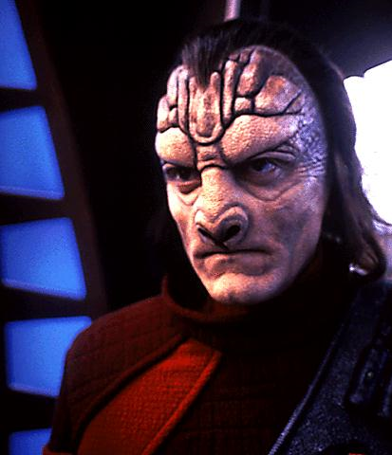
The Hunters.
Affiliation; (Presumed) Dominion.
Homeworld; Unknown (Gamma Quadrant)
The Hunters are a species that have evolved with a love of hunting. Their deep, almost spiritual connection with the hunt has led to a strict code of rules that govern the law of the hunt. For a species conducting such a barbaric pass-time, they have elevated the blood sport to what they feel is a highly civilised level.
Hunters
Attributes:
Fitness; 3
Co-ordination; 2,
Dexterity +1
Intellect; 3,
Perception +1
Presence; 2,
Empathy -1,
Psi; 0
Skills:
Athletics (Choose Specialisation) 2 (3)
Culture (Hunters) 2 (3)
Dodge 1
History (Hunters and the Tosk) 1 (2)
Language; Dominion 2
Science, Any (Choose Specialisation) 1 (2)
Word Knowledge (Homeworld) 1 (2)
and one of the following;
Hunting (Choose Specialisation) 1 (2)
or Tracking (Choose Specialisation) 1 (2)
or Search 1
Typical Advantages/Disadvantages:
Code of Honour (Hunters Code) -2
Code of Honour (Hunters Code) -2
This code of honour is developed purely as a credo between the Hunters and the Tosk, both groups believe in it to an almost religious level. This code of honour allows the Tosk free reign to lead the hunt wherever they may wish, and give the Tosk a reasonable head start. Some Tosk have even led the Hunt off-planet thanks to this.
Once the hunt has begun in earnest the Tosk may accept help, but may not reveal the nature of the hunt, nor ask for help. It must be freely given, and a Tosk may be joined by others of their own free will. These others will also become objects of the hunt. The hunt will continue until either the quarry is killed or captured in shame, or until all the hunters are dead.
Finding little sport in the hunting of animal life outside of necessity, they have spent a millennia developing as a civilisation, much like humans, but while the human love of Blood Sports died out in their 21st century, the Hunters continued. Once their civilisation had elevated to the level of genetic manipulation their hunt was saved.
They created a race of beings, the Tosk, who were intelligent and capable, and lived solely to serve their society as quarry for their hunts. These hunts are quite fair and a Tosk who manages to evade the Hunters can remain alive for quite a while, it is also fair for a Tosk to obtain armaments and fight back, leading to a more exciting and enjoyable hunt. The Tosk see nothing wrong in this way of life, the spirituality of the hunt is equally strong in their people as the Hunters that created them. And in return the hunters care for the Tosk outside of the hunt, they idolise them as worthy opponants and cunning quarries.
The reptilian nature of both the Tosk and Hunters, and the admission that the Tosk were an artificially created species specifically for the purpose of hunting. Along with the hunters choice of Dominion energy weapons has led Starfleet Intelligence to make much speculation from the sole encounter with either of these species at DS9 in 2369, and speculation seems to point to the Tosk as perhaps a prototype for the Jem’Hadar with the Hunters perhaps serving as original genetic stock, however no proof of this speculation has been substantiated. To date the hunters have kept their word and never brought their hunt through the wormhole again, baring travel through it as part of the rules of future hunts, and Starfleet has been unable to locate their homeworld. See also The Tosk

#Note. A (civilian) Hunter career template can be found in 'Among the Clans', the Andorian sourcebook, which will serve suitably in this respect.
Hunters Equipment.
Uniform and Scanners
Hunters were bright Crimson bodysuits, with heavy black boots. They wear a metallic helmet offering slight protection. This helmet has an effective scanner unit, enabling target acquisition and tracking. The scanner in the helmet functions as a Tricorder.
Weapons
Their primary choice of weapon is the Dominion Jem'Hadar Rifle. Like most Gamma quadrant species if any trade is done, it must be done with the Dominion, and the founders well aware of the distraction of the hunt with these people have allowed them to retain limited stocks. But whether that is as customer or producer is unknown.
Armour
The Hunters do not wear armour, as it is seen as a slur on the individuals skills. Instead they do wear a device mounted on their forearms, this device is capable of absorbing the discharge from an energy weapon. Provided a Hunter can successfully block a shot (requiring a suitable roll on Dodge, or Hand to Hand Block skills), the energy bar can absorb and dissipate up to 30 damage per shot. Damage levels over that will bleed through to the wearer.
Once hit the bars glow for a short wil (1 round), as they bleed off the energy, and during this time they cannot be used to block further shots.
