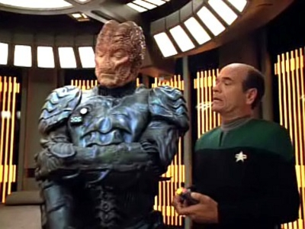
Hirogen
By DanG

Affiliation. Independent
Location. Delta Quadrant
Main Export. None
Description and Background Notes

The Hirogen are a nomadic species, their history is ancient and they are considered a threat by many who encounter them.
Hirogen
Attributes:
Fitness 3 [7]
Vitality +1
Co-ordination 3 [6]
Reaction +1
Intellect 2 [5]
Presence 2 [5]
Psi 0 [5]

Skills:
Athletics (Climbing) 1 (2), (Running) (2)
Culture (Hirogen) 2 (3)
History (Hirogen) 1 (2)
Language, Hirogen 2
Primitive Weaponry (Hirogen Talon) 1 (2)
Search 1
Stealth (Stealthy Movement) 1 (2)
Hunting (Choose Specialisation) 1 (2)

Typical Advantages/Disadvantages:
Resolute +3; Arrogant -1, Code of Honour (Hunter's) -2, Obsessive Tendencies (The Hunt) –3

The Hirogen are a species driven by the hunt, who highly prize the unusual trophies derived from the carcasses of their prey, these trophies are often indicators of a hunters status within their society, their sociological structure is built around the ideal of a space faring nomadic hunting packs or tribes, with a hierarchical structure in which an 'alpha' individual leads and a 'beta' and 'gamma' are secondary subordinates. Intermittent contact is maintained over vast distances between tribes by an ancient communication network, however the dispersal of the tribes had made such contact The ritualistic hunt is reinforced through the depiction of the application of paint to the armour before a hunt.
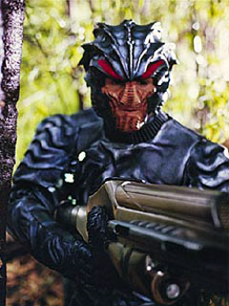
Physically, the Hirogen are typically much taller and stronger than humans, usually over two metres in size with a muscular build evolved for combat. Their sensory perception is acute and quite useful for a hunting species. The Hirogen also possess an impressive immune system for attacking foreign bodies.
Most commonly wear their hunting armour, which also serves as an environment suit in inhospitable environments. The vast majority of the Hirogen are hunters and this makes them primary members of their species, however some Hirogen fill supporting roles such as Technicians, these Hirogen are often considered weak and second class citizens, and as such are often ignored by the pack, even if they fill a vital role.
After several encounters with the Starfleet vessel USS Voyager, the Hirogen became aware of Holographic technologies, initially they sought to turn the USS Voyager into a Holographic Hunting Park, but eventually they were fought off and control of the USS Voyager returned to its crew. However they were provided with Holographic technologies which were then utilised to make sentient holograms to hunt. These holograms were self aware and revolted against the hunt, several escaping and forming a rebellion, fighting back against the Hirogen, ironically pleasing many of the Hirogen themselves who were not all happy with the lack of trophies associated with hunting holograms…
It has been theorised that the Hirogen may have once been a strong interstellar empire, and as such, their home world may have been an early victim of the Borg, with the surviving Hirogen forming these nomadic tribes and admiring status through strength as a defence against such an overwhelming enemy. Such conjecture however will likely remain lost in the mists of time, even to the Borg who have no current designation for the Hirogen.
Hirogen Equipment.
Hirogen Armour is a tough metallic plate armour, heavy and deliberately unwieldy, to wear it is a mark of honour amongst Hirogen Hunters, and each hunter will often decorate his armour with war paint and trophies, it can also serve as an environment suit on inhospitable planets with the application of breathing mask. The armour offers +3 armour protection against physical and energy weapon damage, but reduces the wearer’s reaction by -1 due to its weight and bulk.
The Hirogen use an arsenal of various formidable weapons picking a weapon that best suits their chosen prey, favouring larger weapons, heavy and imposing. 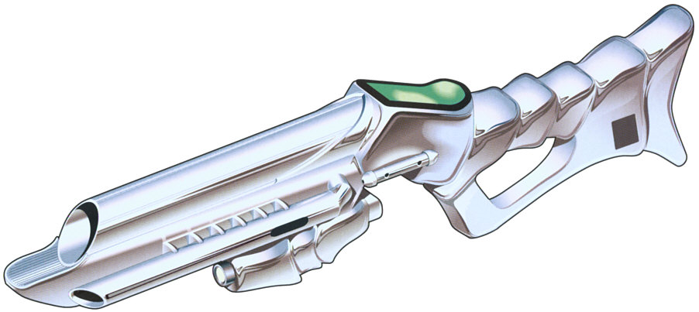
The standard Hirogen hunting weapon is a Tetryon-based rifle, with a sensor display that helps a hunter to track his prey. They are also fitted with a device that seems to function much like a tricorder, which reveals bio-data on the captured prey.
Damage 20+4D6 (uses 20 charges per shot)
Range 5/20/50/150
Size 1metre long
Mass 3kg
Energy 1000 charges
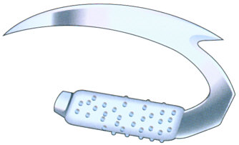
The Hirogen also favour a bladed weapon called a Talon for hand-to-hand combat. Its curved nature making it a very instinctive weapon, and easy to use, but less useful in defence.
Size 65cm
Mass 1.6kg
Accuracy 7
Block 0
Damage 5+3D6
The Hirogen Communications Network.
The Hirogen communications network was an ancient array of relay modules which spanned the Delta Quadrant, and reached as far as the Alpha and Beta Quadrants as well, hinting at a significant stellar empire.
The series of modules, dating back over 100,000 years in age, was claimed by the Hirogen as their property during the 24th century, however it is unknown if the Hirogen were the originals builders of the network. The communications network was first encountered by the Federation by the USS Voyager in 2374. One of the arrays encountered by Voyager was powered by an artificial quantum singularity, generating almost four terawatts of energy.
Using the relay network, Voyager was able to locate the USS Prometheus, a Starfleet vessel on the edge of the Alpha Quadrant, and attempted to communicate with it. However, the message quickly became degraded, and bounced back to Voyager. It was determined that a holographic data stream would not suffer degradation to the same extent, and so Voyager sent their EMH to the Prometheus to make contact.
When the Hirogen operators and controllers of the network, discovered Voyager's use of their technology, they attempted to cut off the ship's connection with the network. When negotiating failed, Seven of Nine sent a feedback surge along the communications link, incapacitating the Hirogen commander.
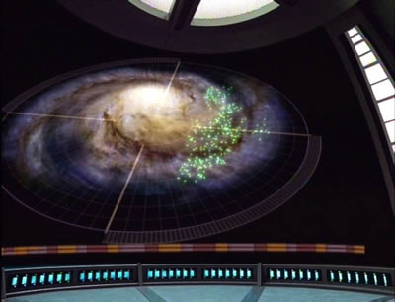
Several weeks later, Starfleet attempted to use the network to contact Voyager directly. However, the same problems with communications caused a large portion of the data transfer, containing messages and letters from the crew's families, to become lodged in a relay station near to Voyager's position. While attempting to retrieve the data, Voyager came under attack from a Hirogen hunting party, and was forced to use an anti-thoron burst against the relay station, causing the quantum singularity within to be exposed, destroying the Hirogen vessel, along with the remaining messages. The energy released in the process spread to every relay in the network, disabling them, and rendering the network inert.
Even with the return of the USS Voyager, SCE Teams are assigned to some of the local relay arrays, and are looking into re-initialising the communications network. Initial experiments are providing positive results. One thing that the network does imply is that if it stretches to the borders of Federation and Romulan territories, that it is also possible that the Hirogen may already have an as yet undiscovered presence within Federation territory.

