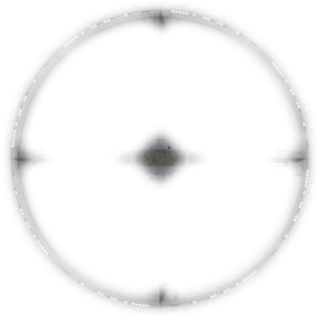
Starbase Specifications
Production Data:
Origin:
Class and Type:
Year Launched:
Hull Data:
Structure:
Size/Decks:
Length/Height/Beam: // Meters
Complement:
Operational Data:
Transporters:
Cargo Units:
Separation System:
Sensor System:
Operations System:
Life Support:
Power System:
Sublight Drive:
Orbital correctors:
Engineering Facilities:
Tactical Data:
Phaser Arrays:
Penetration:
Photon Torpedoes:
Penetration:
Deflector Shield:
Protection Threshold:
Docking Data:
Docking Bay:
Shuttlebay:
Shuttlecraft:
Docking Ports:
Docked ships:
Pylons/Berths:
Docked ships:
Tractor Beams:
Miscellaneous Data:
Manoeuvre Modifiers: +C, +H, +T
Traits:

History:

Mission:

Features:

Facilities in Service:

