Starfleet Uniform
Ranks and Departments
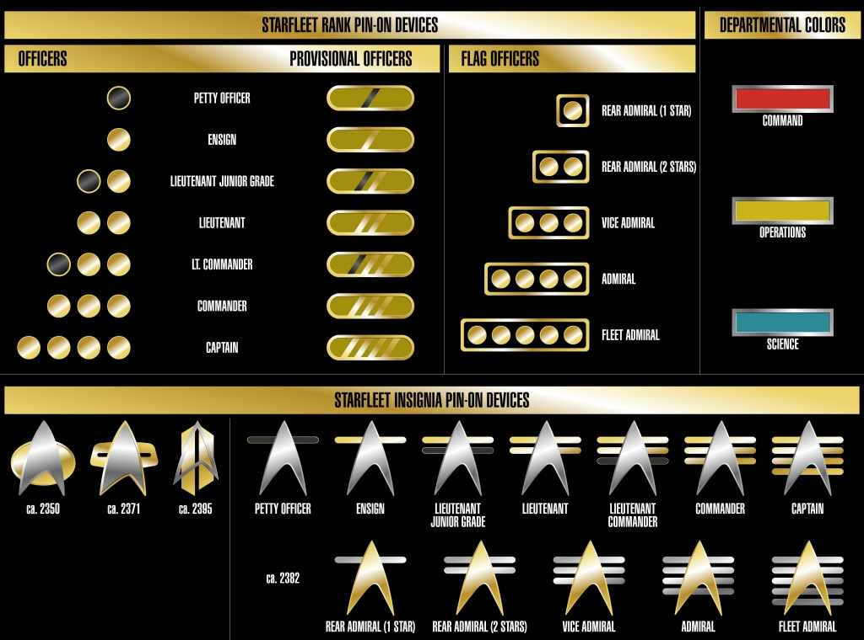

Duty Uniform and Variants.
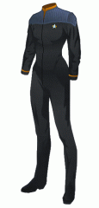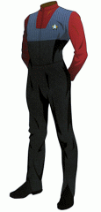
The standard Starfleet Duty uniform consists of black trousers and a jacket worn over a coloured undershirt. The Undershirt denotes the department, and rank insignia are worn on the raised soft collar, on the right. Comm Badges are worn on the crewman’s left chest, and are molecular bonded to the shirt, but can be easily removed and placed on another top. Each Comm Badge is assigned to the crewmember and constantly linked to the local Starfleet computer, which allows the ships systems to identify location and serves as a low-level transporter pattern enhancer.

Standard alternative designs for the duty uniform are a single-piece jumpsuit worn with the undershirt, and even a female skirt and boots option, and standard equipment often assigned are the Tricorder and Type 2 Phaser, these are worn in pouches which are usually added to holster these devices during an away team.
A light vest in the same design as the jacket can also be worn as an alternative to the standard duty uniform jacket.

Cultural Affectations are allowed by Starfleet regulations, as long as such affectations are considered important to the Crewmembers original culture, Starfleet greatly adheres the philosophy of IDIC, and makes these allowances for serving officers. Commonly this is simply a case of tailoring the standard uniform template to better suit the officers physiology, but can also include non-uniform items. Examples include (but are not limited to);
- Bajorans are allowed their earring on their right ear lobe
- Human Sikh Officers are allowed their Turban and Ceremonial Dagger. The Turban is either worn in uniform grey, black or in the departmental colour.
- Officers from tribal cultures are allowed their tribal tattoo’s
- Commander Worf (Klingon) wore a Klingon Bandolier and occasionally carried his Met’Leth on Away Missions
- Lieutenant Nog (Ferengi) wore a Ferengi head wrap with the same limitations as Sikh turbans.
Alternate Duty Uniforms;
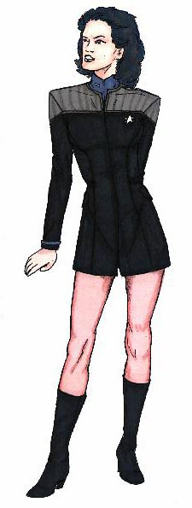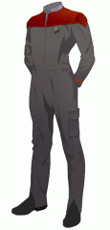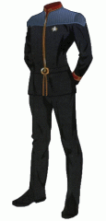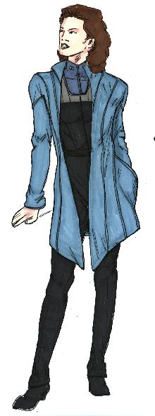
Alt. Female Dress Cadet Uniform Admirals Uniform Medical Lab Coat

Diplomatic/Counsellor Female Duty Dress
Starfleet continues to allow their Counsellors the option of wearing suitable civilian clothes usually a suit for male counsellors or suitable female ‘business’ attire, although counsellors are expected to wear uniform if required. It was noted that male counsellors tended to prefer their uniform while female counsellors felt it too imposing and rigid. In response Starfleet has issued an alternate duty uniform for female counsellors to suit their less formal role and also suitable for the various diplomatic functions that seem to fall to the role of counsellor. A long dress using the colour pattern of the 2360’s uniform is now available for any that wish it.
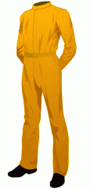
Engineering Coveralls
A protective engineering suit is now available for the Engineering department, offering tool storage and low level radiation protection. This is a harder wearing outfit that better suits the rigours of their job and is available as an alternative to the standard duty uniform. Usually issued and worn most commonly by non-com engineering crew.
Away Team Jacket
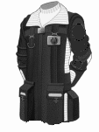
A new Away Team Jacket has been re-introduced, patterned on the model issues in the late 23rd century, this is issued in the black and grey of the standard uniform, and worn over the undershirt or vest. The Jacket features large pockets for equipment stowage and offers increased protection for the wearer. (2 points armour against energy weapons 4 points melee, but has -1 reaction due to encumbrance). The large collars of the model from 2270’s remains, and displays the wearers departmental colour or in white for issue to non-Starfleet mission specialists. The away team jacket is also designed for RRT use replacing the unpopular Black combat BDU’s that has been formerly issued.
Dress Whites
Dress uniforms are a small white jacket and black trousers with Comm badge and rank insignia. The formal nature of occasions where Dress Uniforms are required often includes strict regulations to optional affectations and alternate patterns are not within Starfleet Regulations. These are also considered suitable attire for formal mess uniform.
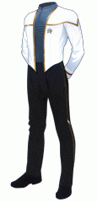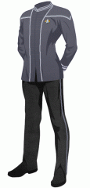

Admiralty Captain Officer Enlisted
PT Coveralls
The standard PT coveralls are a lightweight tracksuit to allow the wearer full freedom of movement and are worn for strong exercise activity. Light grey with short sleeves, the display the wearers departmental division in a colour band at 3-quarters across the chest. Typically only worn by cadets, most serving officers prefer civilian exercise gear.
Desert Issue Fatigues.


On hot climate worlds, desert issue fatigues may be issued, a lightweight trouser T-shirt combination in off-white with the crewmembers division colour worn prominently.

A long robe/coat is also issued to protect the crewmember from heat and to help avoid sunstroke.



Away Team Wetsuit
A full-body wetsuit is now available for underwater missions. This is issued in standard Starfleet patterns and resembles the interim uniform of the late 2360’s with a black bodysuit and the departmental colour across the shoulders. For ease of identification and observation underwater brighter shades of the departmental colours are used. The suit includes webbed gloves and boots giving a +1 to swimming checks, and includes a small computer, battery-pack and force field generator, enabling the suit to provide a protective breathing helmet and replicate various levels of buoyancy and protection against pressure. Typically the diving range allows up to 1 hour within normal tolerances with just the standard suit systems.
Type-3 SEWG Environment Suit (EVA)
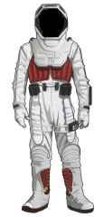
Standard issue spacesuit, designed for comfort and lightweight. Protecting its wearer from extreme environmental pressure (ranging from zero atmospheres/vacuum to five atmospheres), and temperature (from -100 to 120 degrees Celsius). The energy signature produced by an EVA suit is deliberately easily detectable by most sensors as a safety feature
Features;
- Osmium Kevlar anti-plasma tinted faceshield
- Integral halogen lamps (shoulder/helmet mounted)
- Primary and Secondary control systems
- Gravity Boots and integral comms systems
- Life Support (air and water recycle) for 25 hours.
- Self repair functions.

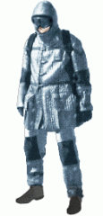
Emergency Survival Suit (Cold Weather)
Standard issue in shuttle and escape pod emergency kits, offering adverse environment protection and equipment storage in case of emergencies, designed to keep the wearer protected from the elements and increase survival rating, for harsh cold environments but where a breathable atmosphere can at least support life. It also includes pouches for ease of access to equipment.

Additional Uniform Types
Starfleet is a wide and varied organisation, and the ease at which a replicators can fashion a new garment for use has meant that over the years a great many variations of duty uniforms for specific purposes have been developed, some of which are more commonly used than others
