

Vidiian
By DanG and Brian K
With thanks to Perrry

Vidiians and the Phage
The Phage is a slow debilitating disease, with no cure. If left untreated it will be fatal for the sufferer. However treatment helps to slow this process. Unfortunately the Phage is highly adaptive and will develop a tolerance for any treatment used.
Vidiian
Attributes:
Fitness 3 [5]
Vitality -1
Coordination 2 [5]
Intellect 3 [5]
Logic +1
Presence 2 [6]
Empathy -1
Willpower +1
Psi 0 [5]
Skills:
Athletics (choose Specialization) 1 (2)
Culture (Vidiian) 1 (2)
History (Vidiian) 1 (2)
Language; Vidiian 2
Science, Any (choose Specialization) 1 (2)
Science, Life (choose Specialization) 2 (3)
or Science, Medical (choose Specialization) 2 (3)
World Knowledge (Vidiian Homeworld) 1 (2)
Typical Advantages/Disadvantages*:
Code of Honour (Oath); Cure the Phage - 3, Medical Condition (Phage) -2*,
Species Enemy (Most species dislike/distrust them) -4
High Pain Threshold +2

Editors Note: Organ redundancy had been considered by BrianK, but I felt that Organs in jars on a shelf saved for later didn't really count...
This requires that Vidiians develop new and innovative means of staving off the disease. It was found that the transplant of healthy organs and body parts also helped slow the spread, but not stop the advance.
Eventually the shortage of healthy body parts and organs led the Vidiians to apply transplants from other species, developing advanced medical techniques to ensure compatibility, usually requiring certain amounts of Genetic re-sequencing. This re-sequencing had an unfortunate side effect, in ensuring the Phage’s compatibility to the transplanted parts, and their eventual debilitation to the disease.
Over the years the sources of legitimate parts began to run dry, and it was simply a matter of time before desperation turned the Vidiians into more than desperate scientists and made them something more, something bad.
By this point the extensive use of transplantation had already turned the species into a Frankenstein mix of grafted skin and transplanted organs, becoming almost universally ugly by all species comparisons, but now their attitudes towards other species became as ugly as their visage.
Code of Honour (Oath);
Cure the Phage (-3)
This code is the primary species goal of the Vidiians and the cause of their fall from grace. At first it was simply a driving goal of an advanced species turning to science to treat a disease rampaging out of control. As a result leading to the Vidiians advancing their medical technologies by leaps and bounds.
But the constant failure of these advances to remedy the problem, caused this driving goal to allow the Vidiians to 'justify' their action as necessary when their attempts at treating the phage made them into monsters...
At first they were choosy, carefully picking targets for potential in curing the Phage, and to keep their activities secret, but soon they were unable to keep their activities secret and hit targets indiscriminately either keeping their prisoners as slave work-crews until such a time as they could harvest the necessary body parts, or simply hitting small groups to take a vital body part required urgently...
The Phage had caused a once proud and peaceful species into a race of nightmare grave robbers...
*Note: The Think Tank cured the Phage in 2375-76, this will allow the removal of 'Medical Condition; Phage' but it will still take a while for the Vidiians to loose their reputation as butchers and horrors...

Vidiian Harvester

Settings: 1-6 (Disruptor)
Range: 5/40/80/150
Size: 10cm long
Mass: 0.8kg
Energy: 600 charges
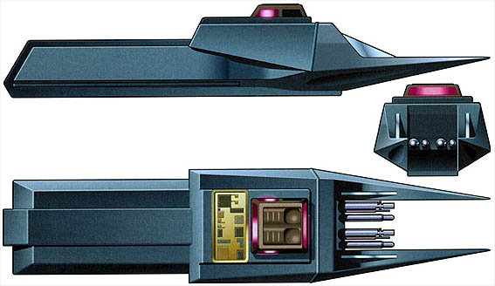
A combination weapon, serving as a Disruptor, Medical Tricorder and Highly Specialised Organ Transport targeting device.
In combat it functions as a standard hand-held disruptor. But the Vidiian are most feared for their organ harvesting.
If the weapon is used on Heavy stun setting to incapacitate a target, at the same time the sensors scan the victims body for healthy organs, which the user can then use the localised transporter enhancement function to remove and transfer to a mobile cryogenic medical storage case linked to the weapons signal pattern.
The weapons range is very short, limited to Point blank and short range only (10-20 meters) for the harvesting functions functions, the harvester ability are very power intensive Using 100 power per usage and the weapons operational capacity in this function is limited to only a few shots.

