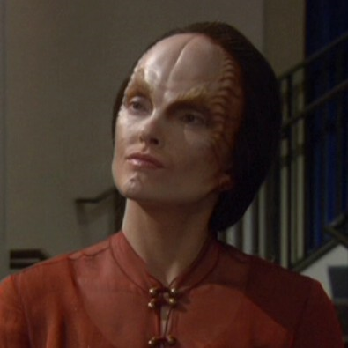
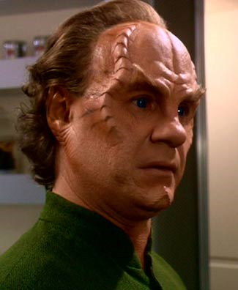
Denobulan
By DanG
Denobulan
Attributes:
Fitness 2 [5]
Coordination 2[5]
Intellect 3 [5]
Presence 2 [5]
Empathy +1
Psi 0 [5]

Skills:
Artistic Expression (Choose Specialisation) 1 (2)
Culture (Denobulan) 2 (3)
History (Denobulan) 1 (2)
Language; Denobulan 2
Science, Any (Choose Specialisation) 2 (3)
World Knowledge (Denobulan) 1 (2)

Typical Advantages/Disadvantages:
+1 Courage Point
Curious +1

A Species with a long history alongside the Federation. A highly developed and advanced culture, they had been allied and trading partners of the Vulcans prior to Earth's first contact in 2063, and were among the first few alien species that humanity encountered. While the Denobulans were not among the founding Federation members, they remained close allies until their formal admission only a few years later, and since that time the Denobulans have become staunch supporters of the Federation.
As a species they value openness and knowledge and display a gregarious, outgoing nature that sets them apart from the emotionless Vulcans. As a species they extol the virtues of learning and the arts, and are strong in Artistic and Scientific fields (they are open to both advanced and alternate paths of learning, and have long combined the two), along with an open, curious nature that seems to embody the Vulcan philosophy of IDIC, it is little wonder that both Vulcans and Denobulans became firm friends and staunch allies and the highly adaptive and emotional nature of the species helped forge a link with the Humans during the years before the founding of the Federation, the two species becoming firm friends at speed. Many conjecture that the Denobulans were the bridging factor between the Vulcans and Humans allowing the core of the Federation to become firm and trusted friends during the early years allowing the two species to work past their differences and become the allies that would eventually form the Federation. Indeed, the Interspecies Medical Exchange program active in the mid 22nd century was indeed an effort to help bring the two species together, initiated by the Denobulan medical council.
Denobulan Culture accepts polygamy, and the number of wives taken by an individual can be viewed as a sign of status, although Monogomist marriages are not unheard of. This is an established practice as Denobulan males are outnumbered by females. The most common marriages leave the average Male Denobulan with between 1-3 wives, and even after marriage, Denobulans value ‘open’ relationships.
The Denobulan's are humanoid in nature, with a pair of cartilage ridges that run from their cheekbone to the top of their forehead, where it tends to disappear under a high receding hairline. Their facial muscles are densely packed, and this is most obvious when a Denobulan grins, giving them a far larger smile than would seem possible to a human, there are other minor differences such as a very long tongue, claw-like toenails and spinal ridges, but these are minor.

