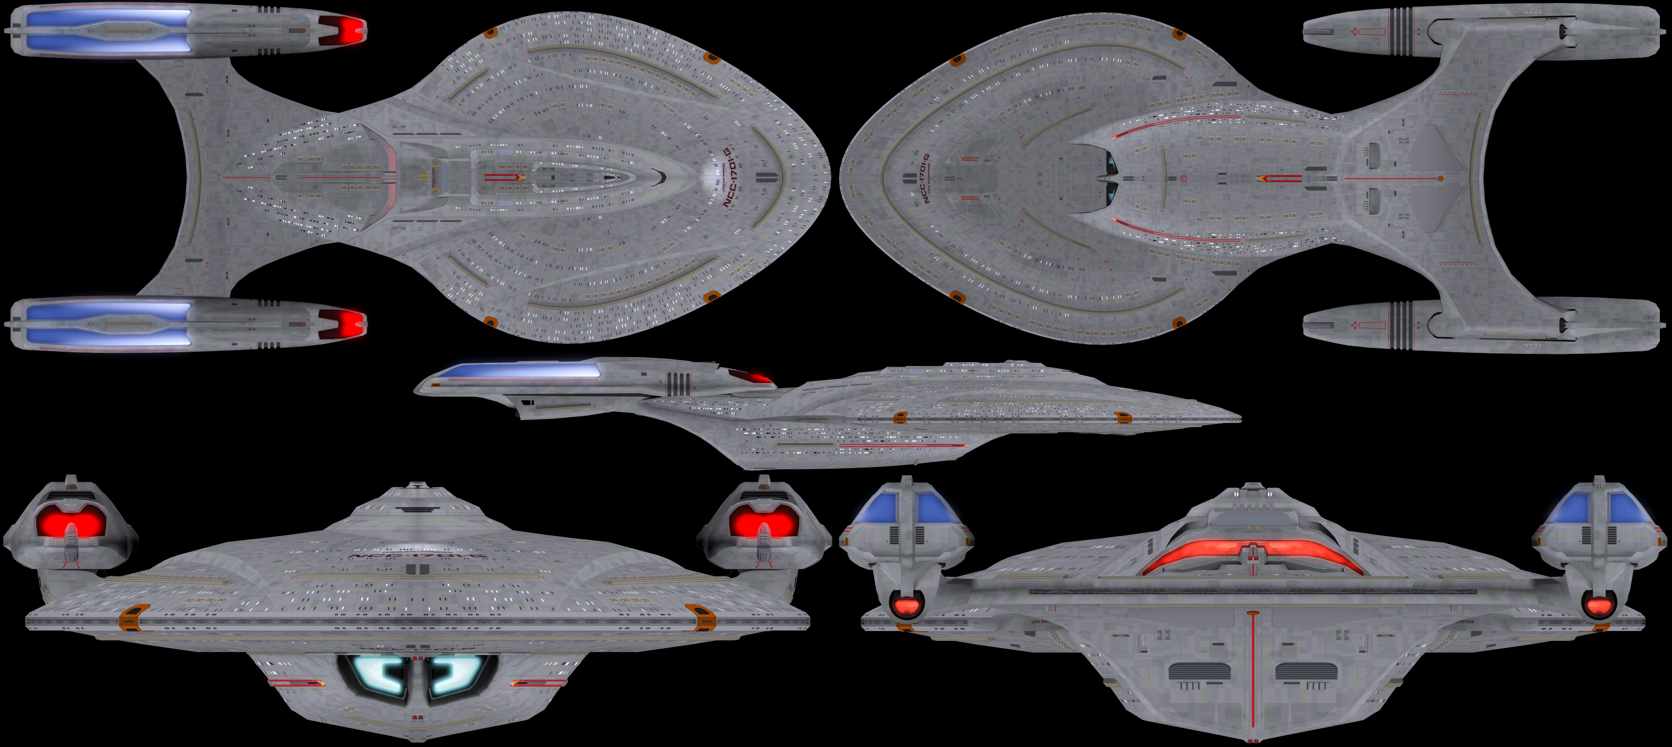

Name: USS Enterprise
Registry: NCC-1701-G
Origin: Federation/Starfleet
Class: Eclipse-class Heavy Explorer
Launched: 2450

HULL DATA
Structure: 90
Hull Size/Decks: 11/59
L/B/H: 1,397/563/182 meters
Mass: 9,450,000 metric tons
Complement: 2,950 crew, 740 passengers, 33,000 evacuation

TACTICAL DATA
Phasers: Type 12 (x13) (F) +10
Penetration: 10/9/9/0/0
Torpedo Launchers: Mk95 DF (x6) (F) +10
Penetration: 14/14/14/14/14 (quantum)
Deflector Shields: FSS-3 (regen) (F) +10
Protection/Threshold: 18/5

PROPULSION DATA
Impulse System: FIHa (0.9c) (F) +11
Warp System: LF-62 (8/9/9.4) (F) +11

OPERATIONAL DATA
Atmosphere Capable: no
Cargo Units: 220
Cloaking Device: none
Life Support: Class 5 (F) +10
Operations System: Class 5 (F) +10
Sensor System: Class 5a(EE)(+5/+4/+3/+2/+1) +9
Separation System: Standard
Shuttlebay: 3 aft
Shuttlecraft: 60 size worth
Tractor Beams: 4 – 1ad, 1av, 1fd, 1ad
Transporters: 18 stand, 18 emerg, 10 cargo

MISCELLANEOUS DATA
Maneuver Modifiers: 3C, 0H, 4T
Edges: Ablative Armor, Famous, Flagship

Saucer Section (Separated): Structure 30, Phaser Penetration (7/7/6/0/0), Torpedo Penetration (6/6/6/6/6), Maneuver Modifier (3C, 1H, 4T), no Warp, Cargo 55, Tractor Beams (2 -1fd, 1fv), Shuttlecraft (30 Size in one bay)
Stardrive Section (Separated): Structure 60, Phaser Penetration (8/7/7/0/0), Torpedo Penetration (8/8/8/8/8), Maneuver Modifier (3C, 0H, 4T), Cargo 165, Tractor Beams (2-1ad, 1av), Shuttlecraft (30 Size in 2 bays)

HISTORY

