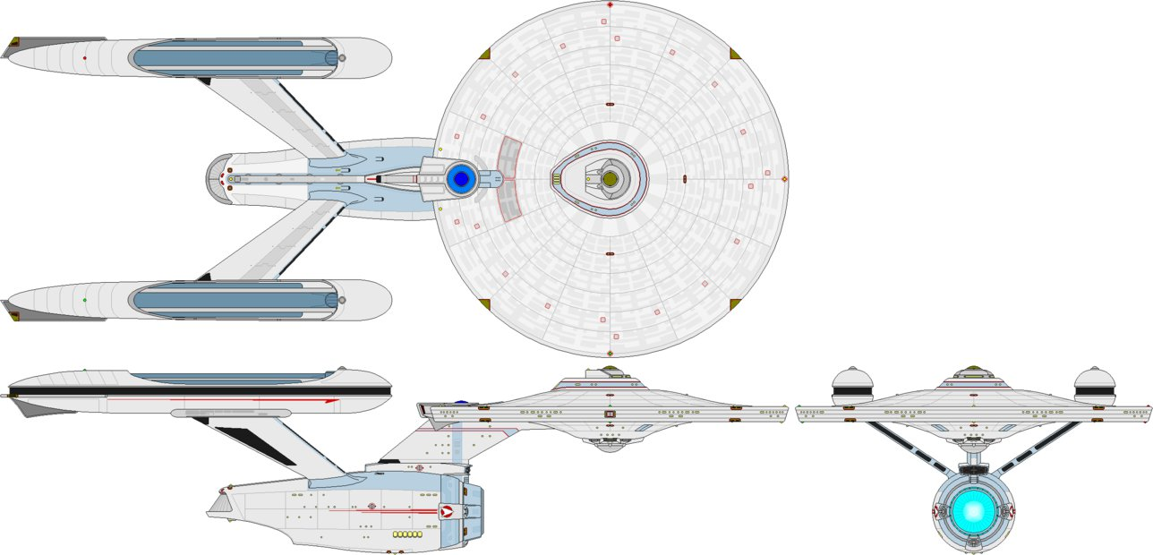
*art by Kelso323
At launch

Name: USS Ticonderoga
Registry: NCC-2232
Origin: Federation/Starfleet
Class: Constitution-class Heavy Cruiser
Launched: 2292

HULL DATA
Structure: 30
Hull Size/Decks: 6/21
L/B/H: 305/141/71 meters
Mass: 211,500 metric tons
Complement: 500 crew, 5 passengers,
2,550 evacuation
TACTICAL DATA
Phasers: Type V (x9) (D) +6
Penetration: 6/6/6/0/0
Torpedo Launchers: Mk 22 DF (x3) (D) +6
Penetration: 4/4/4/4/4
Deflector Shields: CIDSS-2 (CC) +5*
Protection/Threshold: 14/3
PROPULSION DATA
Impulse System: RSM (0.75c) (DD) +7*
Warp System: LN 63 Mod 4 (8/10/13 OCU) (DD) +7*

OPERATIONAL DATA
Atmosphere Capable: no
Cargo Units: 80
Cloaking Device: none
Life Support: Class 3 (D) +6
Operations System: Class 3 (D) +6
Sensor System: Class 3A (CC) +5 (+3/+2/+1/+0/+0)
Separation System: Emergency
Shuttlebay: 1 aft
Shuttlecraft: 6 size worth (no larger than 2 ea)
Tractor Beams: 2 – 1fv, 1a
Transporters: 4 standard, 2 emergency, 2 cargo

MISCELLANEOUS DATA
Maneuver Modifiers: 2C, 0H, 3T
Edges: Battle Tested, Prototype System(*) (Impulse, Warp, )

2357 Relaunch

Name: USS Ticonderoga
Registry: NCC-2232
Origin: Federation/Starfleet
Class: Constitution-class Heavy Cruiser
Launched: 2292

HULL DATA
Structure: 35*
Hull Size/Decks: 6/21
L/B/H: 305/141/71 meters
Mass: 211,500 metric tons
Complement: 500 crew, 5 passengers,
2,550 evacuation
TACTICAL DATA
Phasers: Type V (x9) (D) +6
Penetration: 6/6/6/0/0
Torpedo Launchers: Mk 22 DF (x3) (D) +6
Penetration: 4/4/4/4/4
Deflector Shields: CIDSS-2 (D) +6*
Protection/Threshold: 14/4
PROPULSION DATA
Impulse System: RSM (0.75c) (DD) +7
Warp System: LN 63 Mod 4 (6/7/9.6 MCU) (DD) +7

OPERATIONAL DATA
Atmosphere Capable: no
Cargo Units: 80
Cloaking Device: none
Life Support: Class 3 (DD) +7*
Operations System: Class 3 (DD) +7*
Sensor System: Class 3A (D) +6 (+4/+3/+2/+1/+0)*
Separation System: Emergency
Shuttlebay: 1 aft
Shuttlecraft: 6 size worth (no larger than 2 ea)
Tractor Beams: 2 – 1fv, 1a
Transporters: 4 standard, 2 emergency, 2 cargo

MISCELLANEOUS DATA
Maneuver Modifiers: 3C*, 0H, 3T
Edges: Battle Tested, Improved Systems(*) (Structural Integrity, Shields, Operations, Life Support, Sensors)

HISTORY
In the late 2280s and early 2290s, relations with the Klingons became increasingly restive, leading many at Starfleet Headquarters to conclude that a new war was inevitable. A number of design studies were undertaken to determine ways that existing ships could be upgraded (such upgrading was quicker than building new hulls and definitely quicker than designing new ships from scratch).

Inevitably, proponents of the Constitution class pushed for inclusion of the venerable design in the upgrade program, despite the general consensus that the class simply had been taken as far as it could go. The urgent need for any advantage that could be found eventually won the debate, and Starfleet R&D set to work.

After careful consideration, the decision was made to upgrade the reliability of the ships' defensive systems and to utilize the data gleaned from the Excelsior-class engine retrofit to improve the design of the nacelles and warp coils. The weapons systems were left alone, except for some enhancements to the tactical sensors and fire control computers.

A number of the newer Constitution hulls were given a quick refurbishment while the systems changes were implemented, beginning with the USS Valley Forge (NCC-2205). Ths resulted in this configuration being dubbed the “Valley Forge subclass”.

In all,15 hulls were upgraded before the unexpected signing of the First Khitomer Accords in 2293. Stipulations in the Accords called for a significant drawdown in active fleets on both sides. Unwilling to simply scrap the Valley Forges, Starfleet elected to mothball the ships against future needs.

In early 2357, a workflow problem new ship construction resulted in the need to pull ships from the reserve yards for temporary duty. Included in the call-up were the 15 Valley Forge hulls. They were taken from their storage berths at the Proxima Maintenance Yards, given a series of system upgrades (Operations, Life Support, and Sensors, plus upgrades to shields and structural integrity). All 15 were returned to active service by the end of the year. Their performance was sufficient for Starfleet to elect to maintain them in the active inventory after the problem was resolved.

As of 2364, 13 of the 15 ships are still in service. Of the other two, one has been lost and the other re-assigned for training purposes.

