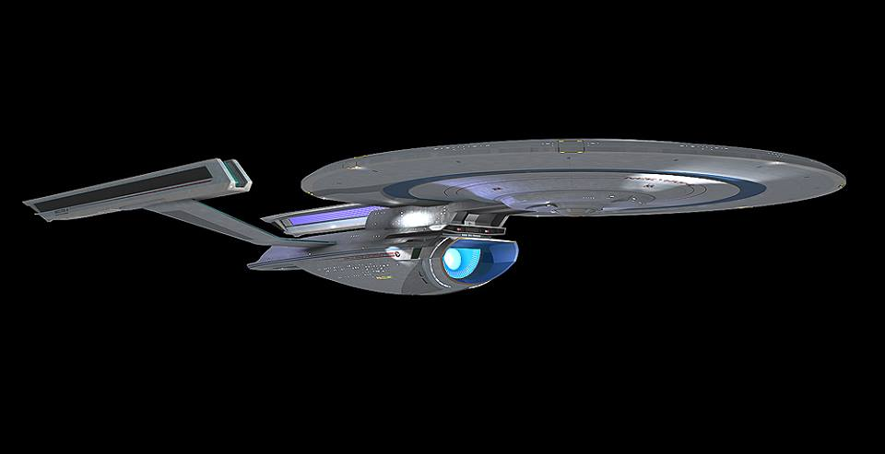
*design by Spencer Perdriau,model by Raul Mamau
At launch

Name: USS Enterpise
Registry: NCC-1701-A
Origin: Federation/Starfleet
Class: Spruance-class Exploration Cruiser
Launched: 2286

HULL DATA
Structure: 70
Hull Size/Decks: 9/28
L/B/H: 730/337/94 meters
Mass: 630,990 metric tons
Complement: 1,125 crew, 20 passengers,
2,250 evacuation
TACTICAL DATA
Phasers: Type VIII (x9) (E) +8
Penetration: 7/7/6/0/0
Torpedo Launchers: Mk 22 DF(x3) (E) +8
Penetration: 5/5/5/5/5
Deflector Shields: CIDSS-2 (C) +4
Protection/Threshold: 14/4
PROPULSION DATA
Impulse System: RSM (0.75c) (DD) +7*
Warp System: LN-64 Mod 3 (7/9/12 OCU) (DD) +7*
OPERATIONAL DATA
Atmosphere Capable: no
Cargo Units: 180
Cloaking Device: none
Life Support: Class 3 (DD) +6*
Operations System: Class 3 (DD) +6*
Sensor System: Class 3a (D) +5 (+4/+3/+2/+1/+0)*
Separation System: none
Shuttlebay: 1 aft
Shuttlecraft: 10 size worth (no larger than 2 ea)
Tractor Beams: 2 – 1fv, 1a
Transporters: 6 standard, 3 emergency, 3 cargo

MISCELLANEOUS DATA
Maneuver Modifiers: 2C, 1H, 3T
Edges: Prototype (Life Support, Operations, Sensors, Impulse and Warp Engines, Maneuvering)

HISTORY
Note: in this timeline, the Transwarp project was cancelled early on with only the Excelsior built (later refitted with conventional warp engines). Starfleet elected to persue the Spruance-class instead.

With the failure of the Transwarp program, Starfleet was left with the dillema of still wanting a leading-edge technology demonstrator that also had significant combat capability due to ongong tensions with the Klingon Empire. The decision was made to instead build a vessel of unprecedented size (730m long, with a standard crew of just over 1,100). The prototype was designated the USS Spruance (NCC-3000).

Emphasis was placed on improving structural integrity as well as inherent hull strength. The warp engines would be an advance on the LN-64 series, utilizing the same type of coils, but in much longer nacelles. The increased number of coils allowed their usage to be staggared, reducing coil wear on any individual coil and improving the reliability of the system.

Upgraded RSM impulse engines were utilized, with additional fusion reaction chambers performing the same funtion at sub-light speeds and having a similar impact on engine reliability. Changes were also made to make the RCS thrusters both more powerful and more responsive because of the need to compensate for a much higher hull mass. (Those changes would prove to be slightly more effective than expected.) Life Support and Operations systems were also tweaked to improve their performance.

The last (and some argued most important) improvement was to incorporate the most advanced sensor package Starfleet had fielded to date. The system's range was increased and additional “hardening” made it less susceptable to natural interferance and jaming/cloaking systems.

The initial weapons configuration was similar to that of the refit configuration of the Constitution class, though with the addition of an aft-firing torpedo tube. Additional power conduit space was allocated in the saucer for an additional 6 phaser banks (4 dorsal and 2 ventral) which would result in a configuration approximating that of the cancelled Excelsior class. (Penetration increases to 8/8/8/8/8.)

The Spruance was due to begin her shakedown cruise in 2286,but it was interrupted by the Whalesong Crisis. The crisis was resolved due to the bravery and ingenuity of Admiral James T Kirk and the command crew of the USS Enterprise, despite their renegade status over the theft and subsequent destruction of their ship. In gratitude, the criminal charges - save one specifically against Kirk - were dismissed. The Spruance was re-christened as the new Enterprise with the registry NCC-1701-A and (now) Captain Kirk and his crew were given command.

