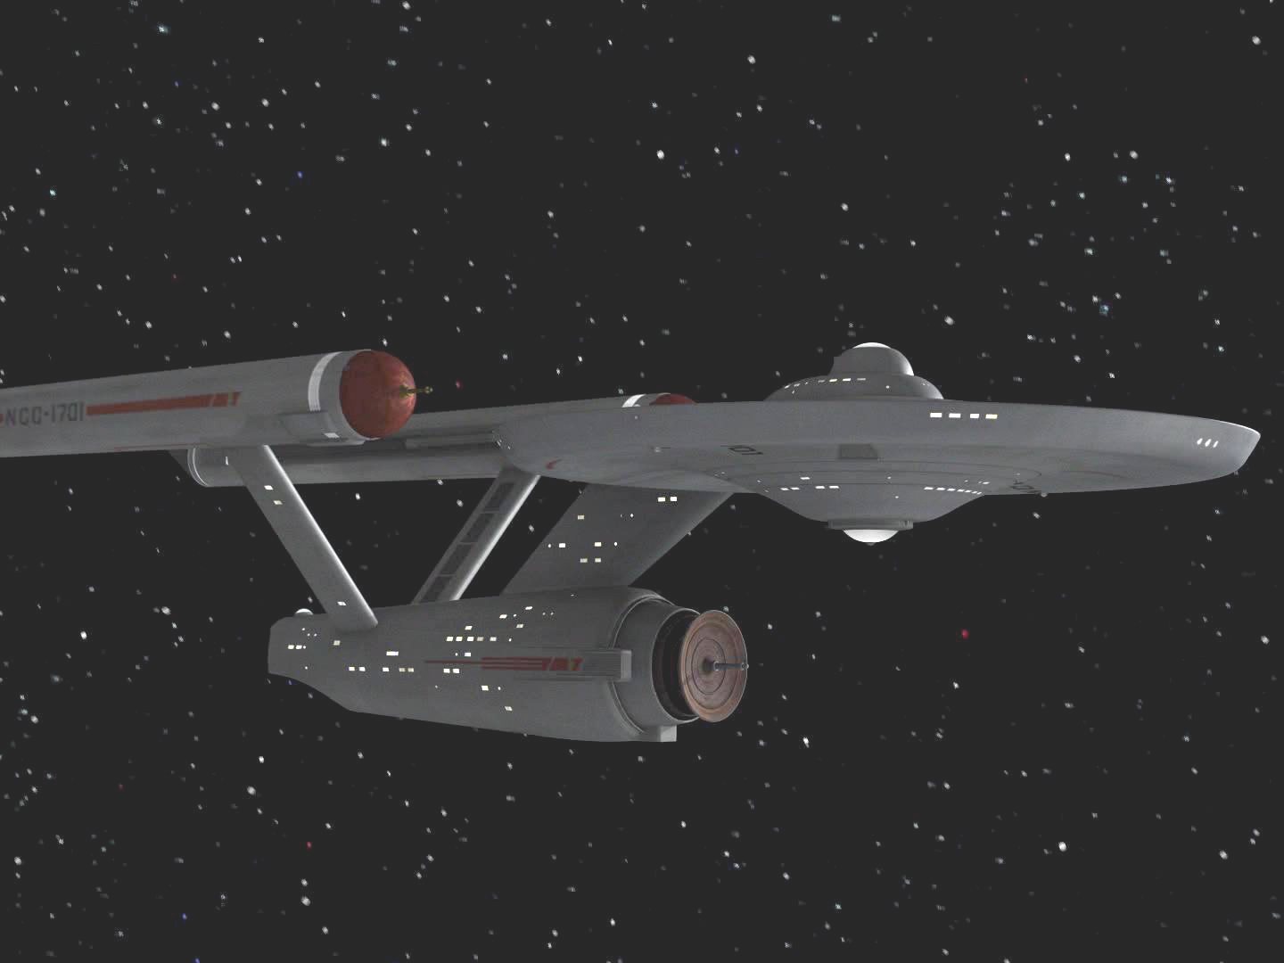
Name: Constitution Class (original)
Origin: Federation/Starfleet
Class: Constitution - class CH
Launched: (2245)

HULL DATA
Structure: 30
Size/Decks: 5/23
Length/Beam/Height: 289/127/73 meters
Complement: 205 crew, 10 passengers,
820 evacuation
TACTICAL DATA
Phasers: Type III (x7) (C) +5
Penetration: 4/4/4/0/0
Torpedo Launchers: Mk 12 IF (x3) (C) +5
Penetration: 3/3/3/3/3
Deflector Shield: PFF-2a (B) +3
Protection/Threshold: 13/3

PROPULSION DATA
Impulse System: SBE (D) +7 (0.5c)
Warp System: PB-16 (C) +5 (5/6/7 OCU)

OPERATIONAL DATA
Atmosphere Capable: no
Cloaking Device: none
Separation System: Emergency
Cargo Units: 70
Life Support: Class 3R (DD) +7
Operations System: Class 3R (DD) +7
Sensor System: Class 3 (D) +7 (+3/+2/+1/0/0)
Shuttlebay: 1 aft
Shuttlecraft: 6 Size worth
Tractor Beams: 1 a
Transporters: 4 standard, 3 emergency, 2 cargo

MISCELLANEOUS DATA
Maneuver Modifiers: 2C, 0H, 2T
Edges: Hardened System (Life Support)
Flaws: none

The original Constitution class was the largest and most ambitious starship design of it's day. The first class of starship to be designed around a five-year deep-space mission profile, the original thirteen ships of this class would set records for durability and endurance that would stand for decades and influence starship design for decades after that. The first hull out of the shipyards (USS Enterprise) would itself become a Starfleet legend under such noteworthy Captains as Robert April, Christopher Pike, and James T. Kirk.

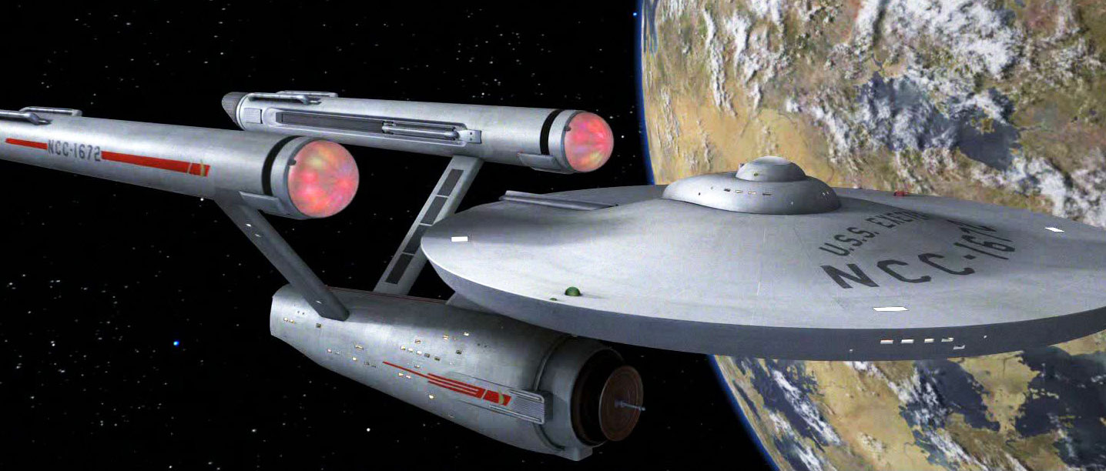
Name: BonHomme Richard subclass
Origin: Federation/Starfleet
Class: Constitution - class CH
Launched: (2260)

HULL DATA
Structure: 30
Size/Decks: 5/23
Length/Beam/Height: 289/127/73 meters
Complement: 430 crew, 10 passengers,
820 evacuation
TACTICAL DATA
Phasers: Type IV (x7) (C) +5
Penetration: 5/5/4/0/0
Torpedo Launchers: Mk 12 IF (x3) (C) +5
Penetration: 3/3/3/3/3
Deflector Shield: PFF-2a (B) +3
Protection/Threshold: 13/3

PROPULSION DATA
Impulse System: SBE (D) +7 (0.5c)
Warp System: PB-32 Mod3 (D) +7 (6/7/8 OCU)

OPERATIONAL DATA
Atmosphere Capable: no
Cloaking Device: none
Separation System: Emergency
Cargo Units: 70
Life Support: Class 4 (E) +8
Operations System: Class 4 (E) +8
Sensor System: Class 3 (D) +7 (+3/+2/+1/0/0)
Shuttlebay: 1 aft
Shuttlecraft: 6 Size worth
Tractor Beams: 1a
Transporters: 4 standard, 3 emergency, 2 cargo

MISCELLANEOUS DATA
Maneuver Modifiers: 2C, 0H, 2T
Edges: Hardened System (Life Support)
Flaws: none

Between 2258 and 2260, the Constitution class underwent significant upgrading including: new phasers, Operational systems (including improved transporters), life support systems (permitting a doubling of crew size) and a new warp drive. The first ship to undergo this conversion was the USS Constellation, followed by the USS Enterprise upon her return from the edge of the galaxy on one of her early missions under her most famous captain James T. Kirk.

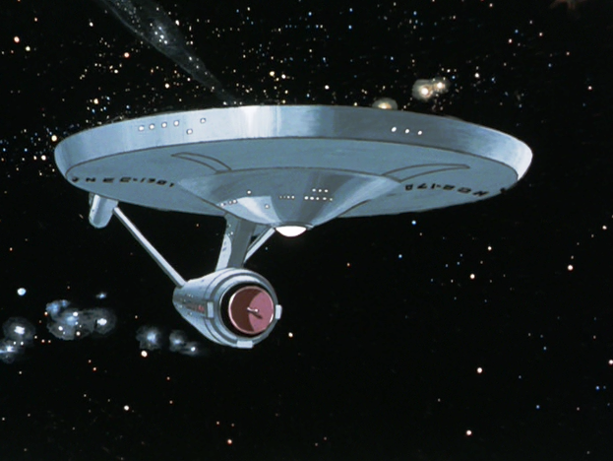
Name: Achernar subclass
Origin: Federation/Starfleet
Class: Constitution - class CH
Launched: (2264)

HULL DATA
Structure: 30
Size/Decks: 5/23
Length/Beam/Height: 289/127/73 meters
Complement: 430 crew, 10 passengers,
820 evacuation
TACTICAL DATA
Phasers: Type IV (x7) (C) +5
Penetration: 6/5/5/0/0
Torpedo Launchers: Mk 12IF (x3) (C) +5
Penetration: 3/3/3/3/3
Deflector Shield: PFF-2a (B) +3
Protection/Threshold: 13/3

PROPULSION DATA
Impulse System: SBE (D) +7 (0.5c)
Warp System: PB-32 Mod3 (D) +8 (6/7/8 OCU)

OPERATIONAL DATA
Atmosphere Capable: no
Cloaking Device: none
Separation System: Emergency
Cargo Units: 70
Life Support: Class 4 (E) +8
Operations System: Class 4 (E) +8
Sensor System: Class 3 (D) +7 (+3/+2/+1/0/0)
Shuttlebay: 1 aft
Shuttlecraft: 6 Size worth
Tractor Beams: 1a
Transporters: 4 standard, 3 emergency, 2 cargo

MISCELLANEOUS DATA
Maneuver Modifiers: 2C, 0H, 2T
Edges: Enhanced System (Warp), Hardened System (Life Support)
Flaws: none

Despite being upgraded only a few years before, several Constitutions received additional upgrades to improve the reliability of their warp engines as well as some minor structural changes early in 2264. These would be the last upgrades made to the class prior to the widespread introduction of the LN series warp nacelles in 2270.

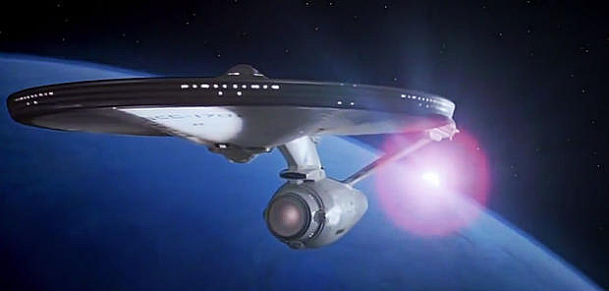
Name: Enterprise subclass
Origin: Federation/Starfleet
Class: Constitution - class CH
Launched: (2271)

HULL DATA
Structure: 30
Size/Decks: 6/23
Length/Beam/Height: 305/141/71 meters
Complement: 430 crew, 10 passengers,
820 evacuation
TACTICAL DATA
Phasers: Type V (x9) (D) +7
Penetration: 6/6/6/0/0
Torpedo Launchers: Mk 6 DF (x2) (D) +7
Penetration: 4/4/4/4/4
Deflector Shield: PFF-3 (B) +3
Protection/Threshold: 14/3

PROPULSION DATA
Impulse System: RSM (D) +7 (0.75C)
Warp System: LN-64 Mod 3 (D) +7 (7/8/12 OCU)

OPERATIONAL DATA
Atmosphere Capable: no
Cloaking Device: none
Separation System: Emergency
Cargo Units: 80
Life Support: Class 4 (E) +8
Operations System: Class 4 (E) +8
Sensor System: Class 3 (D) +7 (+3/+2/+1/0/0)
Shuttlebay: 1a
Shuttlecraft: 6 Size worth
Tractor Beams: 2 (1fv, 1a)
Transporters: 4 standard, 3 emergency, 2 cargo

MISCELLANEOUS DATA
Maneuver Modifiers: 2C, 0H, 3T
Edges: Battle Tested, Prototype (Torpedo +1)
Flaws: none

The return of the USS Enterprise from her first five-year mission under James Kirk marked a milestone in the history of the class, as she was the only surviving hull of the first 13 constructed. The decision was made to completely rebuild her with the most current technology available. After an 18 month refit process the result was a ship best described as an “almost totally new Enterprise”. She was rushed into service in 2271 in response to the V'ger Crisis. Following that she proceeded on her shakedown cruise which was highly successful, leading Starfleet to use her as the template for upgrading the entire class.

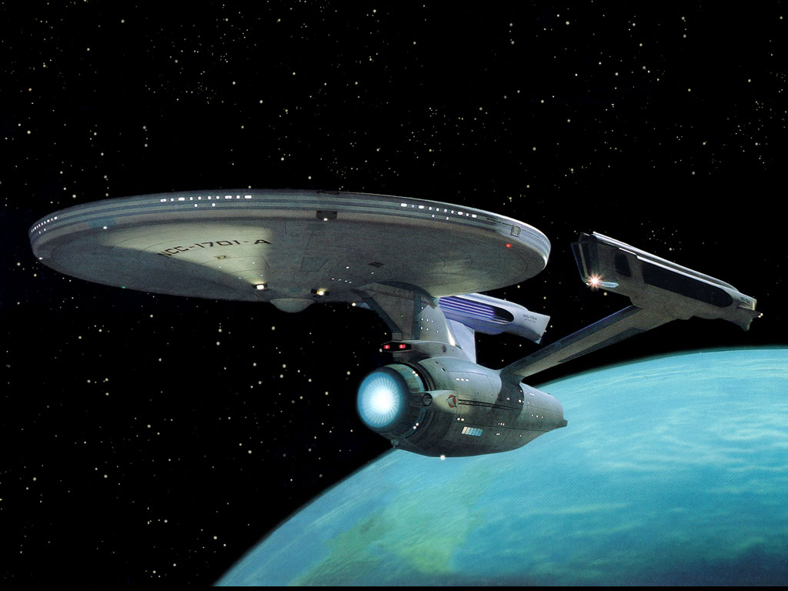
Name: Enterprise-A subclass
Origin: Federation/Starfleet
Class: Constitution - class CH
Launched: (2286)

HULL DATA
Structure: 30
Size/Decks: 6/23
Length/Beam/Height: 305/141/71 meters
Complement: 500 crew, 10 passengers,
820 evacuation
TACTICAL DATA
Phasers: Type VI (x9) (D) +7
Penetration: 6/6/6/0/0
Torpedo Launchers: Mk 6 DF (x2) (D) +7
Penetration: 4/4/4/4/4
Deflector Shield: CIDSS-1 (AA) +2
Protection/Threshold: 13/3

PROPULSION DATA
Impulse System: RSM (D) +7 (0.75C)
Warp System: LN-64 Mod 3 (D) +7 (7/8/12 OCU)

OPERATIONAL DATA
Atmosphere Capable: no
Cloaking Device: none
Separation System: Emergency
Cargo Units: 80
Life Support: Class 4 (E) +8
Operations System: Class 4 (E) +8
Sensor System: Class 3A (CC) +6 (+3/+2/+1/0/0)
Shuttlebay: 1a
Shuttlecraft: 6 Size worth
Tractor Beams: 2 (1fv, 1a)
Transporters: 4 standard, 3 emergency, 2 cargo

MISCELLANEOUS DATA
Maneuver Modifiers: 2C, 0H, 3T
Edges: Battle Tested
Flaws: Glitchy Systems (Operations, Transporters)

The starship Yorktown was several severely damaged by energy emissions from an alien probe during the Whalesong Crisis of 2286. Following the resolution of that event, it was salvaged and towed back to Earth for repair and refitting. Upgrades included new phaser emitters, new shield generator, and improved sensor systems. In gratitude for the courage and ingenuity displayed by the then-renegade command crew of the destroyed USS Enterprise in resolving the crisis, the Yorktown was re-christened as the new Enterprise with the registry NCC-1701-A.

Unfortunately, the upgrades proved to be less successful than Starfleet had hoped. The crew of the Enterprise reported numerous systems problems upon their return from her shakedown cruise. At first, residual damage from the ship's encounter with the probe was suspected, though Engineering captain Montgomery Scott was able to resolve the problems. Subsequently, however, other ships who had undergone the same upgrades began to report similar issues. The eventual cause was traced to fundamental programming conflicts between the new systems' software and the ship's core operating system. Program patches were applied, but occasional problems persisted. In the end the upgrade package was only fitted to a small number of ships before being discontinued entirely.

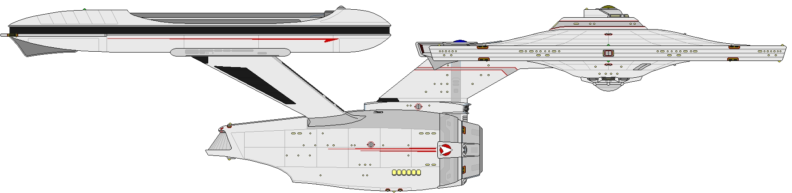
Name: Valley Forge subclass
Origin: Federation/Starfleet
Class: Constitution - class
Launched: (2292) (relaunched 2359)

HULL DATA
Structure: 30
Size/Decks: 6/23
Length/Beam/Height: 305/141/71 meters
Complement: 500 crew, 10 passengers, 820 evacuation (2292)
250 crew, 85 passengers, 820 evacuation (2355)
TACTICAL DATA
Phasers: Type VII (x9) (E) +9
Penetration: 7/7/6/0/0
Torpedo Launchers: Mk 22 DF (x3) (E) +9
Penetration: 6/6/6/6/6
Deflector Shield: CIDSS-2 (C) +5
Protection/Threshold: 14/4

PROPULSION DATA
Impulse System: RSM (D) +7 (0.75c)
Warp System: LN-64 Mod 3 (D) +7 (8/10/13 OCU) (2292) (6/7/9.9MCU) (2359)

OPERATIONAL DATA
Atmosphere Capable: no
Cloaking Device: none
Separation System: Emergency
Cargo Units: 80
Life Support: Class 4 (E) +8
Operations System: Class 4R (EE) +9 (2292)
Class 5 (F) +10 (2359)
Sensor System: Class 3A (D) +8 (+4/+3/+2/+1/0)
Shuttlebay: 1a
Shuttlecraft: 4 Size worth
Tractor Beams: 2 (1fv, 1a)
Transporters: 4 standard, 3 emergency, 2 cargo

MISCELLANEOUS DATA
Maneuver Modifiers: 2C, 0H, 3T (2292)
3C, 1H, 3T (2355)
Edges: Battle Tested, Enhanced Systems (Impulse, Warp)
Flaws: none

As relations with the Klingon Empire deteriorated rapidly in the late 2280s and into the early 2290s, Starfleet began positioning itself for a new war. Part of this program included upgrading as many existing ships as possible within the projected timeframe when open hostilities would erupt.

Proponents of the Constitution class took the opportunity to press for one more refit of the venerable design. After due consideration, Starfleet authorized a package of system upgrades that was mindful of the problems encountered with the Enterprise-A upgrade and which was designed to prevent them from happening again. The package also took advantage of experience gained from refitting the Excelsior class with conventional warp technology, including a new nacelle design.

Phasers, torpedoes, and shields were updated (and an aft-firing torpedo tube added), as were Operations systems and sensors. The changes proved wildly successful during the shakedown of the first ship to be refit (the USS Valley Forge), and a total of 15 of the “youngest” Constitution hulls were upgraded to the new configuration before the signing of the First Khitomer Accords resulted in a draw-down of Starfleet strength.

Not wanting to waste the work, Starfleet placed the Valley Forges in reserve status against future needs. They were reactivated and refurbished in 2359 due to a workflow problem at Utopia Planetia which delayed the completion of several new-build hulls and are expected to serve until at least the end of the century.

