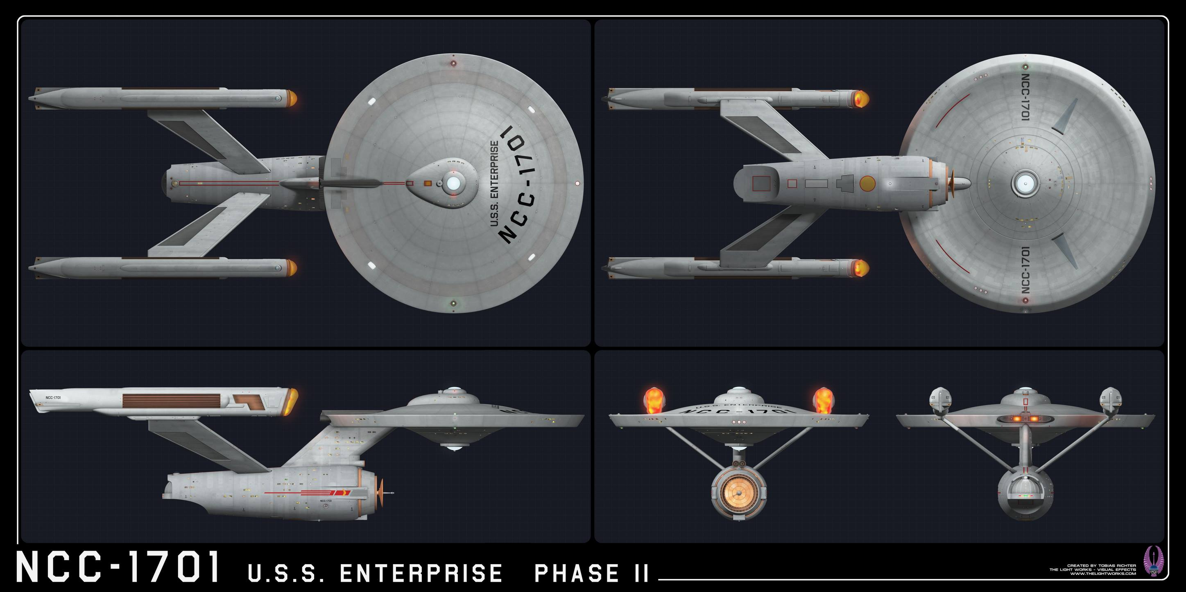
Name: Constitution (II) subclass
Origin: Federation/Starfleet
Class: Constitution - class CH
Launched: 2271 (proposed)

HULL DATA
Structure: 35
Size/Decks: 5/23
Length/Beam/Height: 302/143/76 meters
Complement: 450 crew, up to 250 passengers,1,300
evacuation
TACTICAL DATA
Phasers: Type IV (x10) (D) +7
Penetration: 6/5/5/0/0
Torpedo Launchers: Mk 6 DF (x3) (CD +7
Penetration: 4/4/4/4/4
Deflector Shield: PFF-3 (C) +5
Protection/Threshold: 14/3

PROPULSION DATA
Impulse System: SBE (D) +7 (0.5c)
Warp System: LN-52 (D) +8 (6/7/9 OCU)

OPERATIONAL DATA
Atmosphere Capable: no
Cloaking Device: none
Separation System: Emergency
Cargo Units: 70
Life Support: Class 4 (E) +8
Operations System: Class 4 (E) +8
Sensor System: Class 3 (D) +7 (+3/+2/+1/0/0)
Shuttlebay: 1 aft
Shuttlecraft: 6 Size worth
Tractor Beams: 1a
Transporters: 4 standard, 3 emergency, 2 cargo

MISCELLANEOUS DATA
Maneuver Modifiers: 2C, 0H, 2T
Edges: none
Flaws: none

In the late 2260s the LN series warp engines were introduced into Starfleet's inventory. Almost immediately plans were drafted to upgrade the Constituion class with the new drive, as well as improving the weapons systems further and installing a new shield system. Despite objections from some that the class had been refit twice in just the last decade, the USS Constitution was stood down and put into the docks at San Francisco Fleet Yards to serve as the test bed. It was quickly discovered that substantial changes would have to be made to the ship's structure in order to accommodate the new engine and other systems.
Work on the Constitution was completed the same month that the USS Enterprise returned from her first historic five-year mission under James Kirk. She was slated to become the second of her class to undergo the refit, but her Chief Engineer (Montgomery Scott) proposed an even more ambitious refit program. After considerable wrangling, Scott's proposal was adopted, and proved so successful that the original plan was scrapped entirely, leaving Constitution the only hull to undergo the original conversion.

