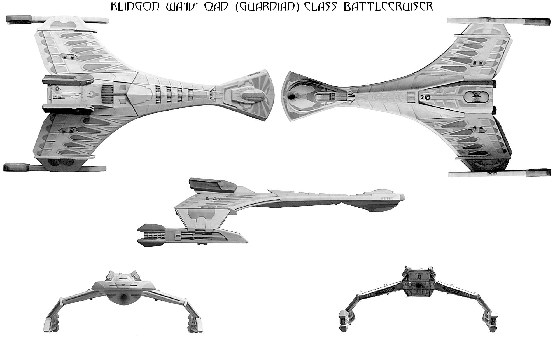
model maker unknown

Name:
Origin: Klingon/KDF
Class: wa' Iv' QaD (Guardian)- class BC
Launched: 2362

HULL DATA
Structure: 40*
Size/Decks: 6/14
Length/Beam/Height: 350/210/91 meters
Complement: 243

TACTICAL DATA
Phasers: KGDM-4 (x6) (D) +7
Penetration: 6/5/5/0/0
Torpedo Launchers: KP-10 (x2) (D) +7
Penetration: 5/5/5/5/5
Deflector Shield: KSE-2 (CIDSS-2) (C) +5
Protection/Threshold: 14/3

PROPULSION DATA
Impulse System: KHEU-4A (0.8c) (D) +7
Warp System: STN-7 (6/8/9) (C) +5

OPERATIONAL DATA
Atmosphere Capable: no
Cloaking Device: Class 3
Separation System: none
Cargo Units: 80
Life Support: Class 3 (D) +6
Operations System: Class 3 (D) +6
Sensor System: Class 3 (+3/+2/+1/0/0/) (D) +7
Shuttlebay: 1 aft/dorsal
Shuttlecraft: 4 Size
Tractor Beams: 2 – 1fv, 1ad
Transporters: 5 standard
6 troop/emergency
3 cargo
MISCELLANEOUS DATA
Maneuver Modifiers: 2C, 0H,3T
Edges: Ablative Armor, Hardened System (Weapons)
Flaws: none

HISTORY
With the signing of the Second Khitomer Accords in 2347, the second major military confrontation between the Federation and the Klingon Empire was brought to a conclusion not only with a cessation of hostilities but an actual alliance between the two galactic powers. This alliance was made possible by the sacrifice made by the crew of the starship Enterprise-C in defense of the Klingon outpost on Narendra III against a Romulan attack, an act considered highly honorable by the Klingon people. Federation negotiators also offered the KDF access to improved sensor and operations technolgies for its ships, as well as additional economic and environmental assistance to the Klingon homeworld, which was still recovering from the Praxis Disaster a half-century before.
In 2350, the KDF took the Federation improvements, as well as advances they had already made in weapons and Impulse engine technolgy and incorporated them into a new class of battlecruiser intended to replace the venerable K'tinga class as the workhorse of the Klinon fleet. This new class would be known as wa' Iv' QaD (literally “One who Protects”, in context “Guardian”).
Guardian class battlecruisers are exceptionally roomy by Klingon standards. The new ship-handling technology gained in the alliance permitted a nearly 35% reduction in operational crew requirements. The space freed up allowed for an expansion of crew quarters as well as expansion of the ship's medical and scientific spaces (previously considered rudimentary at best by most standards). This did not mean that the class was not designed to be a warship, however. At need, some or all of the crew areas could be reconfigured to contain triple the amount of crew barracks-style for extened combat operaions.
The construction process took just under 10 years, and in 2362, the first 10 Guardians were commissioned into the Imperial Fleet. Construction continues at several shipyards, and an additional 15 hulls per year to be delivered for a total projected class size of at least 300.

